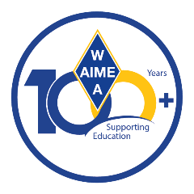
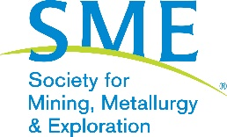

WAAIME Communications Subcommittee
Volunteer Position Description

Summary
WAAIME’s vision is to invest in students of all ages to help address workforce challenges in the extractive industries. A division of SME, WAAIME awards scholarships to students in the U.S. and South America and hosts programs that support students pursuing university studies in the extractive industries. These efforts are made possible through the dedication of WAAIME volunteers.

Communications Subcommittee members play a key role in helping WAAIME stay connected with its members and the mining community through timely, welcoming, and informative messages throughout the year.

What You’ll Do
As a Communications Subcommittee volunteer, you may:
- Send up to five emails per month welcoming new WAAIME members.
- Create engaging posts for the WAAIME LinkedIn page.
- Assist with drafting and reviewing copy for member outreach and program communications.
- Provide suggestions and feedback to the Communications Subcommittee Chair to improve messaging and engagement.
- Support additional communications projects as interest and capacity allow.

Requirements
- Access to an email account.
- No prior communications experience is required; training and guidance will be provided.
- Interest in supporting students, volunteers, and the mission of WAAIME.

Onboarding
- New volunteers will participate in a virtual onboarding session to learn more about WAAIME, the Communications Subcommittee, and available tools and resources.

Time Commitment
- As little as 1 hour per month for ongoing member communications.
- Opportunities to contribute more time for larger or special projects, based on your availability and interest.
- Volunteers are encouraged to communicate their availability with the Communications Subcommittee Chair.

Why Volunteer
Thank you for considering this opportunity to volunteer with WAAIME. Your time and perspective help strengthen our community and support the next generation of mining and engineering professionals.

For questions or to express interest, please contact waaime@smenet.org.

