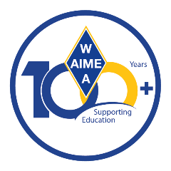
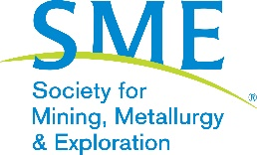

WAAIME Scholarship Reviewer – volunteer role

Summary
WAAIME’s vision is to invest in students of all ages to help address workforce challenges in the extractive industries. Each year, WAAIME—a division of SME—awards scholarships to students in the US and South America. Our volunteer leadership helps make this possible.

As a scholarship reviewer, you will:
- Review assigned scholarship applications online.
  - No prior experience required—training provided.
- Conduct brief interviews with applicants via phone or video conferencing.
- Provide recommendations to the Scholarship Chair for final approval.

Guidelines
- Students are not eligible to be scholarship reviewers.
  - We welcome you as a reviewer after your graduation.
- Attend a live onboarding session or meet with the Scholarship Chair by December 31
- Be available in January & February for reviews, interviews and follow-up.

Onboarding Sessions:
- You must attend a live training session or meet one-on-one with the Scholarship Chair before completing scholarship reviews. These are scheduled in December.
  - Contact us for live-session dates or to schedule a one-on-one.

Time Commitment:
- January – February: Complete reviews online as applications are assigned
  - Scholarships are assigned as they are submitted January 1 – 25.
  - All reviews & interviews must be completed February 10.
- Estimated total time: 5–10 hours, depending on number of applications
- Communicate your availability with the WAAIME Scholarship Chair.

Scholarship Timeline
- December: Reviewer orientation
- January 1: Applications open
- January 25: Application deadline
- January 30: References deadline
- February 10: All reviews & interviews completed

Thank you for considering this opportunity to volunteer with WAAIME. Your time and input help shape scholarship decisions and impact the next generation of mining and engineering professionals.

Please contact us with any questions at waaime@smenet.org

